3.10 - Labs (2)

* **Lab 3.10.8 (1) Using pseudorandom values - a little lottery [B]**

#include <iostream>

#include<cstdlib>

#include<ctime>

using namespace std;

int main()

{

unsigned int maxball, ballsno, num;

cout << "Max ball number? ";

cin >> maxball;

cout << "How many balls? ";

cin >> ballsno;

unsigned int* randBall = new unsigned int[ballsno];

srand(time(NULL));

for (unsigned int i = 0; i < ballsno; i++)

{

num = rand() % maxball + 1;

randBall[i] = num;

cout << randBall[i] << " ";

}

cout << endl;

delete[] randBall;

return 0;

}

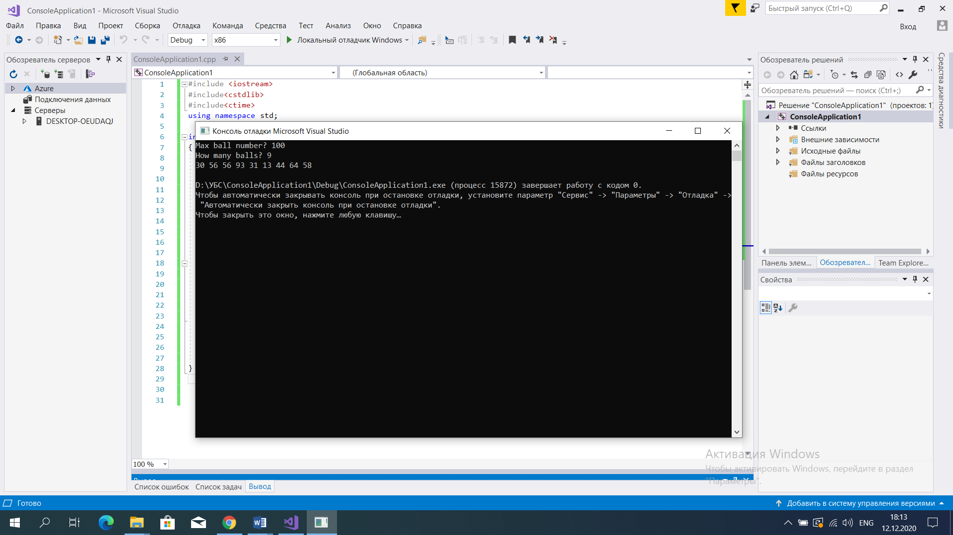

* **Lab 3.10.8 (2) Dynamic data - how to obtain it and how to get rid of it [A]**

#include <iostream>

#include<cstdlib>

#include<ctime>

using namespace std;

struct Collection

{

unsigned int elno;

unsigned int* elements;

};

void AddToCollection(Collection& col, unsigned int element, int i)

{

if (col.elno == 0)

col.elements[0] = 0;

else

col.elements[i] = element;

}

void PrintCollection(Collection col)

{

cout << "[ ";

for (unsigned int i = 0; i < col.elno; i++)

cout << col.elements[i] << " ";

cout << "]" << endl;

}

int main()

{

Collection collection = { 0, NULL };

unsigned int elems;

cout << "How many elements? ";

cin >> elems;

srand(time(NULL));

collection.elno = elems;

collection.elements = new unsigned int[collection.elno];

for (unsigned int i = 0; i < elems; i++)

AddToCollection(collection, rand() % 100 + 1, i);

PrintCollection(collection);

delete[] collection.elements;

return 0;

}

